







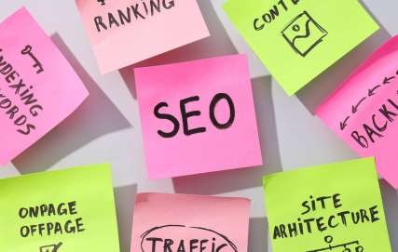










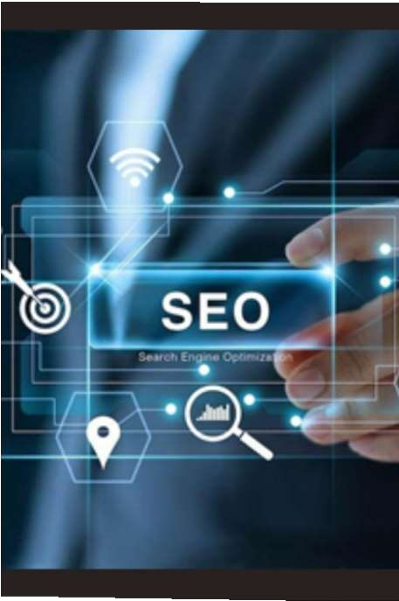





SEARCH ENGINE OPTIMIZATION
Let’sgoall in SEO!

W H A T IS
SEO ?
Search Engine
Optimization

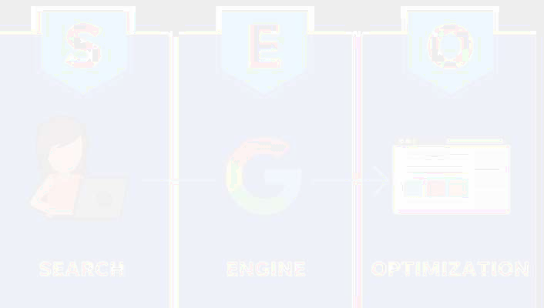
It is the process of making your website more visible in search engines like Google without paying .
SEO improves the user experience, it can also lead to better engagement and conversion rates, plus increased traffic from other sources—not just search engines.


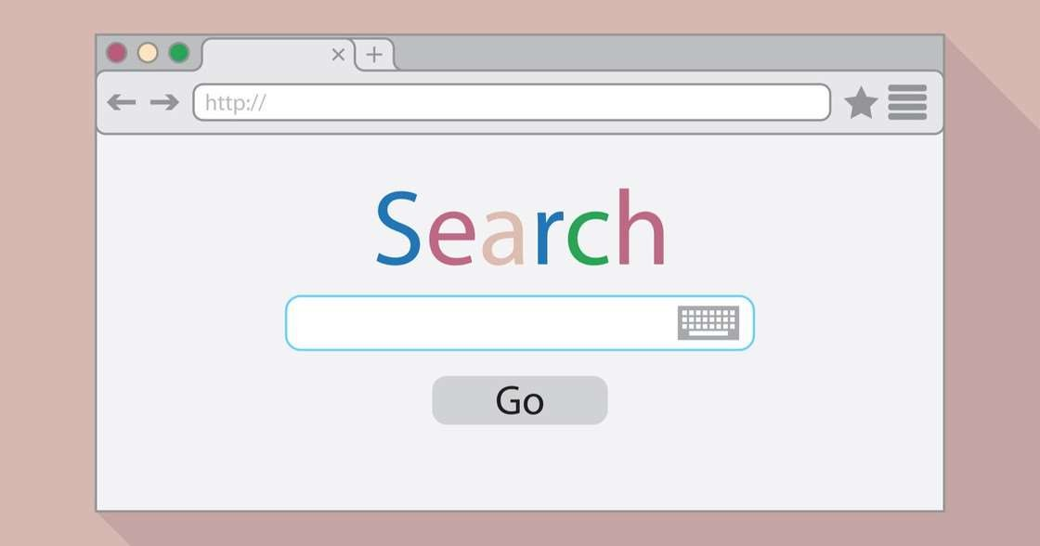
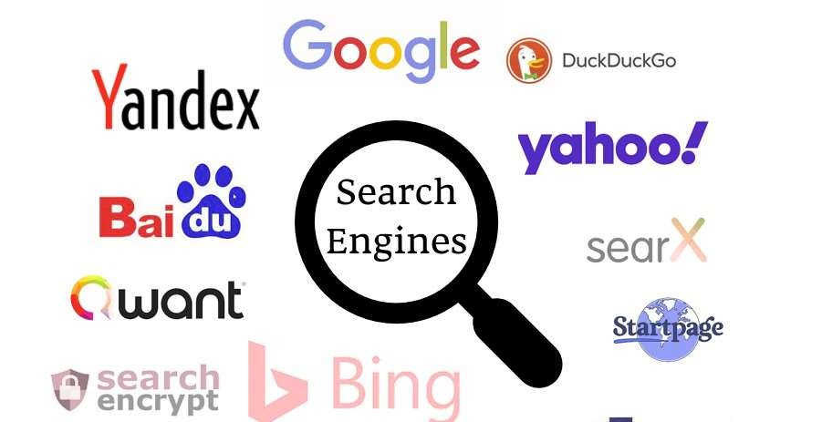
Whatis SearchEngine

A s e a r c h engine is a software system t h a t provides hyperlinks to web pages, a n d o t h e r relevant
information on the W e b in response to a user' s query. The u s e r enters a query in a web b r o w s e r or a mobile app, a n d the s e a r c h results are
typically presented as a list of
hyperlinks a c c o mp a ni e d by textual s u m m a r i e s a n d images.

HowGoogleSearchWorks?

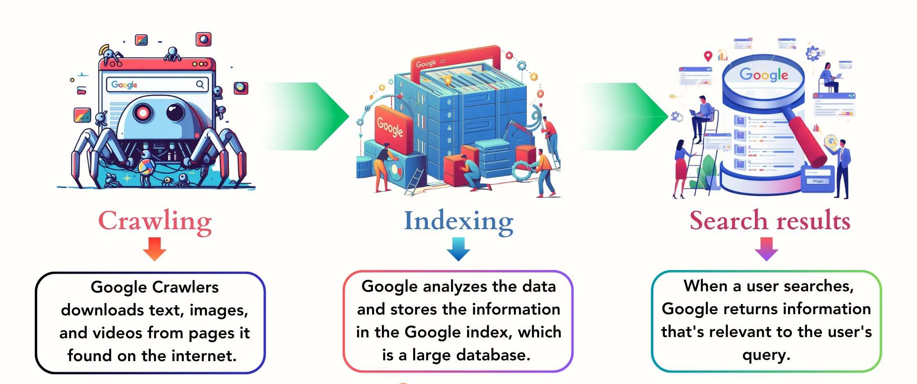

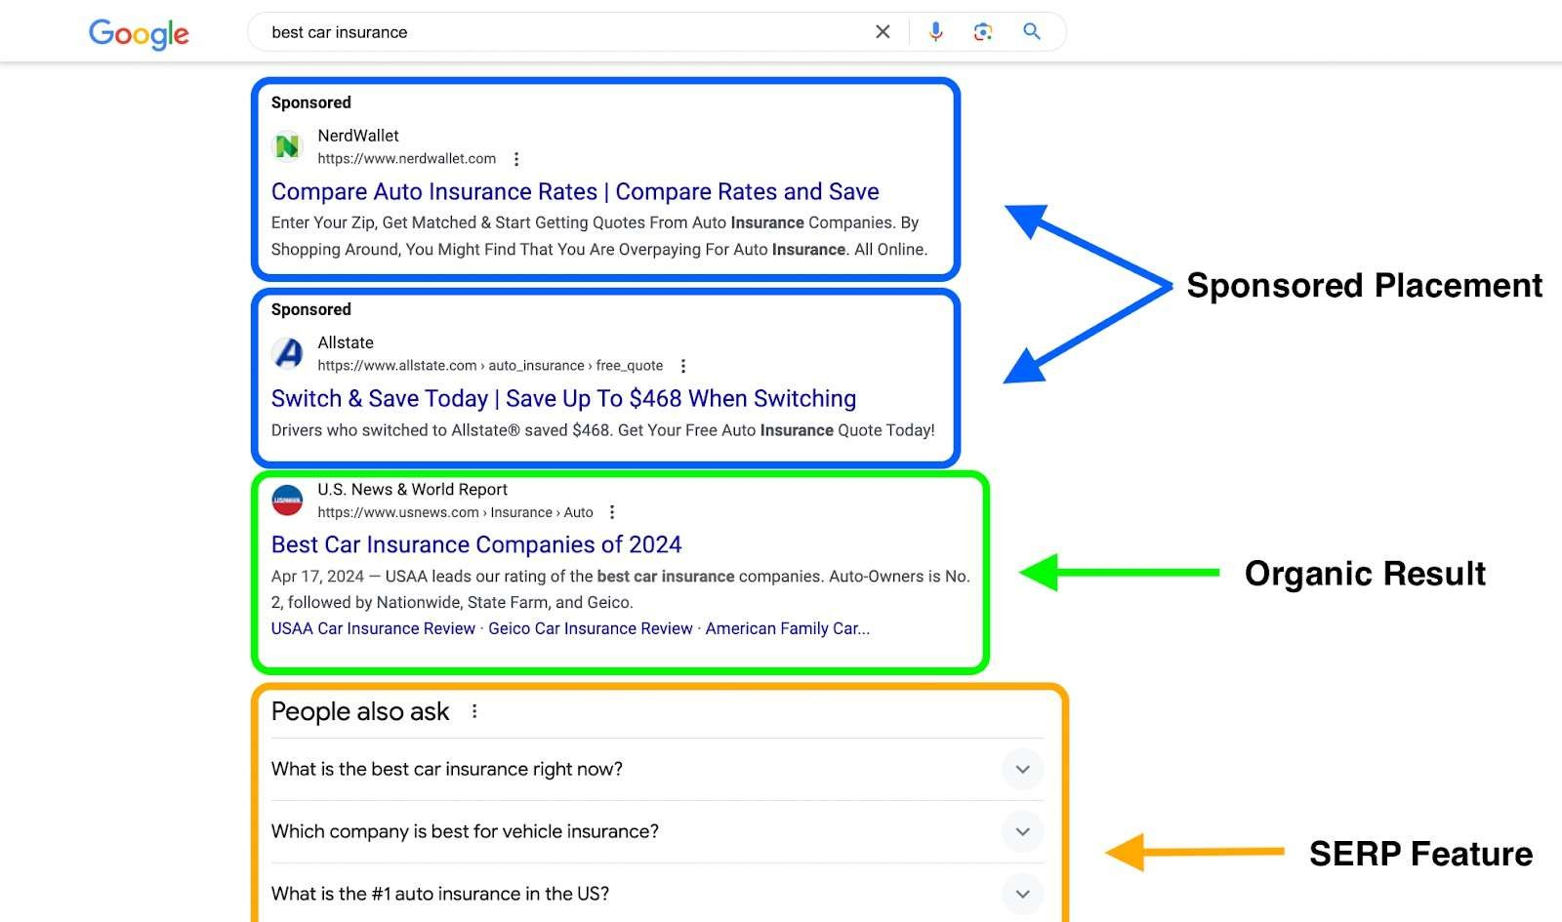
WhatareSearchEngineResultsPages(SERPs)

Type of SEO | Description
On-Page SEO | Optimizing individual web pages to improve their search engine rankings and attract more traffic.
Off-Page SEO | Through external factors like backlinks, strategies focused on improving a website's authority and popularity.
Technical SEO | Optimizing the technical aspects of a website to improve its crawling and indexing by search engines.
Local SEO | Targeting local customers by optimizing a website for local search results.



Whyis On-PageSEOImportant?

Improved Rankings: On-page SEO can help improve the ranking of individual web pages in SERPs, leading to increased organic traffic. Increased Click-Through Rate (CTR): By optimizing title tags and meta descriptions, on-page SEO can increase the CTR of search results, leading to more visitors to the website.
Improved User Experience: On-page SEO can improve the user experience by making web pages more relevant, informative, and engaging. This can lead to increased time on site, lower bounce rates, and higher conversion rates.
Better Crawlability and Indexability: By optimizing the structure and content of a web page, on-page SEO can make it easier for search engines to crawl and index the page, ensuring that it appears in relevant search results.

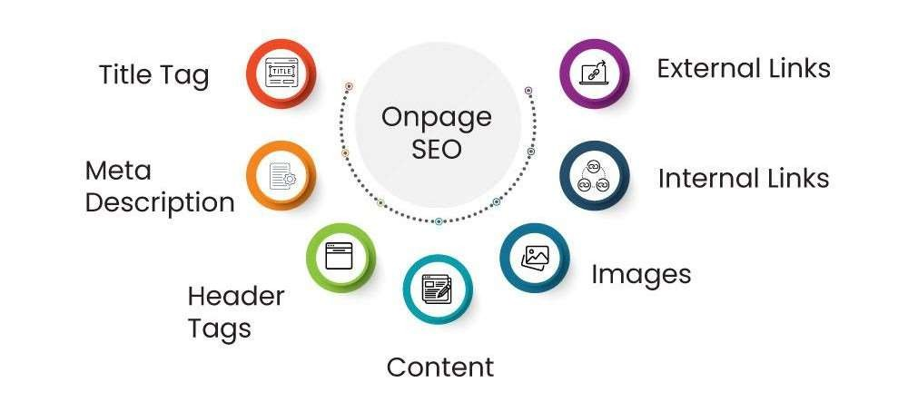



Whyis Off-PageSEOImportant?

Improved Rankings: Off-page SEO can help improve the ranking of a website in SERPs, leading to increased organic traffic.
Increased Brand Awareness: Off-page SEO can help increase

brand awareness by promoting the website on social media, building relationships with other websites, and engaging in other online activities.
More Backlinks: Off-page SEO can help build backlinks from other

websites, which can improve the authority and popularity of the website in the eyes of search engines.
Increased Traffic: Off-page SEO can help drive traffic to the website
by increasing brand awareness, building backlinks, and engaging with potential customers on social media.

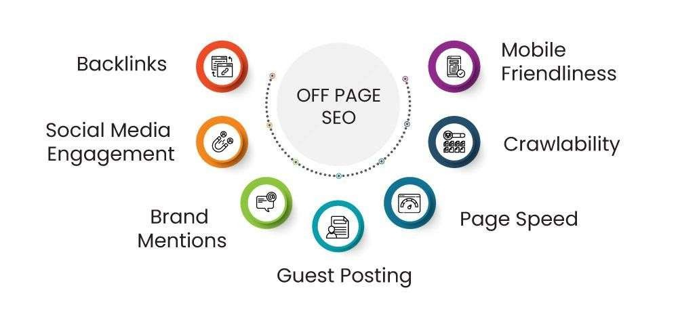



Whyis TechnicalSEOImportant?
Improved Rankings: Technical SEO can help improve the ranking of a website in SERPs by making it more accessible to search engines and users.
Increased Organic Traffic: By improving the website's structure, speed, and mobile-friendliness, technical SEO can increase organic traffic to the website.
Better User Experience: Technical SEO can improve the user experience by making the website faster, easier to navigate, and more secure. This can lead to increased time on site, lower bounce rates, and higher conversion rates.
Improved Crawlability and Indexability: By optimizing the website's structure and code, technical SEO can make it easier for search engines to crawl and index the website, ensuring that it appears in relevant search results.

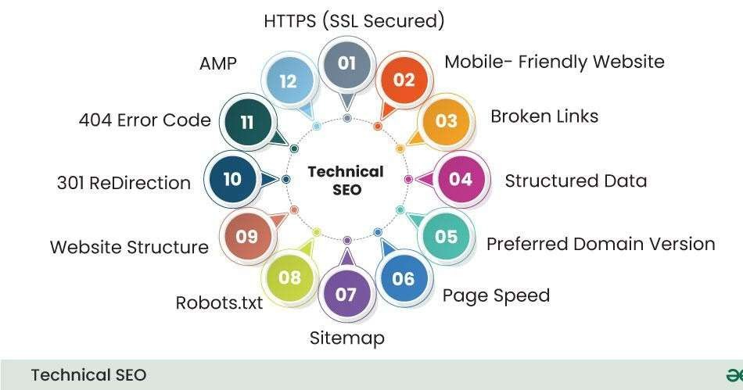




Whyis LocalSEOImportant?

Local SEO (Search Engine Optimization) is another type of SEO Optimization ,which is a set of strategies and techniques used to optimize a website and its content to improve its visibility and ranking in local search results. It focuses on targeting specific geographic locations and promoting a business's presence in local search engines, directories, and maps.
It is one of the types of SEO that helps in increasing the visibility of a business in local search results, attract more local customers, and drive more foot traffic to a physical store or office. It involves optimizing a website for relevant local keywords, building citations and backlinks from local sources, managing online reviews, and optimizing Google My Business and other local business listings.

CommonSEOMistakestoAvoid?
Even sma l mistakes in SEO can hurt your rankings or stop your site from getting traffic. Here are common SEO mistakes to avoid –
Stuffing too many keywords on one page Missing title tags or meta descriptions

Not making your site mobile-friendly Slow website speed
Publishing duplicate or thin content
Messy or unclear site structure
Leaving outdated content online Not using HTTPS
Avoiding analytics and SEO tools

Frequently Asked Questions (FAQs)
- How long does it take to see results from SEO?
Seeing results from SEO usually takes 3–6 months. Businesses learning what is SEO and how it works should focus on consistent strategies like on-page SEO, off-page SEO, and technical SEO. When applied together, these types of SEO improve visibility, organic traffic, and customer acquisition in digital marketing.

- Is SEO relevant for all types of businesses?
Yes. Whether it’s e-commerce or local shops, knowing what is SEO in digital marketing is valuable. A search engine optimization example includes local SEO, where small businesses use Google Business Profiles, keywords, and backlinks to attract customers. Every industry benefits by applying types of SEO strategies for growth.

- How often should SEO strategies be updated?
SEO strategies need updates every few months. Understanding what is SEO means adjusting to algorithm changes, adding fresh content, and improving technical performance. Businesses that know what is SEO in digital marketing also review search engine optimization examples like schema markup and Core Web Vitals to maintain rankings.
- Can SEO guarantee my website will be the first on search results?
No strategy can guarantee the top spot. What is SEO and how it works involves building relevance, trust, and authority using types of SEO such as keyword optimization, backlinks, and technical improvements. SEO boosts visibility, but rankings also depend on competition, content quality, and user engagement signals.

Thank You

